Author : **A.S.M.Damunugalla**

Date: **22/12/2024**

Student ID: **w2121298**

**Outcomes**

**15/06/2024**

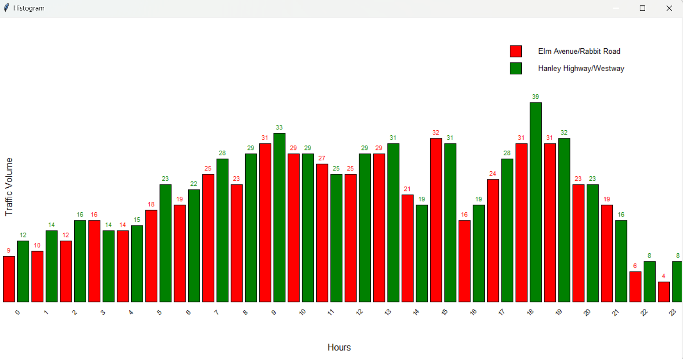

**16/06/2024**

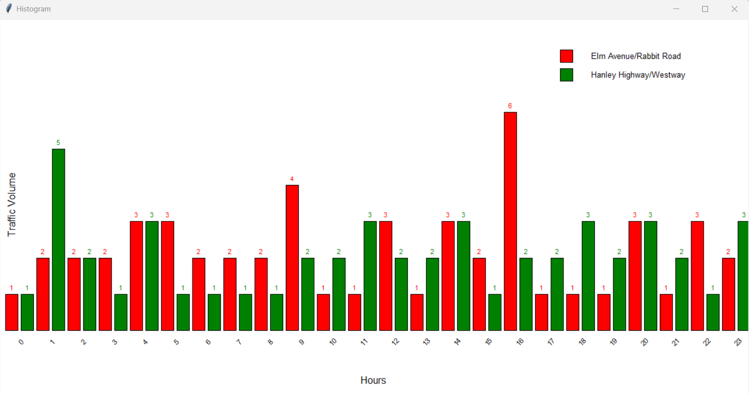

**21/06/2024**

